Milk Bar

“The girl who hugs dogs
is teased by the boys
across the street.
The twang of their taunts
Is like a chorus of demons.
She has no friends here …
Except of course for …”

Damian Balassone

School refusers like her? She didn’t know. But she met them at the humble corner shop, her local milk bar and hung out with them.

Remember those days: First job. First kiss. First cigarette? You could have been loitering along Acland Street St Kilda instead during the early 1970s.

But when you had Mondayitis and took a Mental Health Day, because you couldn’t bear that chorus of school bullies, you got on your Dragstar with your dog tied by its lead to the handle bars, and as fast as you both could travel, you zig-zagged down neighbouring streets to either Inkerman Street Milk Bar in St Kilda, or Prahran East Milk Bar to be with your friends.

Greeted, you sat relaxed in the idle company of ones like yourself, munching on mixed lollies: bananas, sherbet bombs, and freckles, that filled a white paper bag and cost only five cents. While one finished sucking on a sunny-boy, another licked the last crumb of a wagon wheel from her lips and another slurped a Blue Heaven milk shake from a metal cup in youthful style. Jean blew bubbles with her chewy or bubble gum, which the most mischievous of us would pop when she wasn’t looking. And we listened to Supertramp’s Crime of the Century and School emanating from the jukebox inside.

Shirley Horne an academic from Melbourne University, who researched the importance of the corner shop as a place of belonging said,

“Breaking down social isolation, especially among marginalised teenagers, the aged, migrants from non-English speaking backgrounds, the disabled and those many living alone, has traditionally been one of the milk bar’s key functions.”

Recently psychologists at the University of Michigan found,

“Social connection at the neighbourhood level is associated with good mental health, and could even reduce heart attacks.”

In December 2018, a group of researchers at Eindhoven University of Technology made an astounding discovery:

“Feelings of loneliness are directly related to satisfaction with one’s social network and neighbourhood attachment”.

Apart from being a prominent entertaining centre, the social relationship function of the local milk bar, as a meeting place for potentially socially isolated individuals cannot be underestimated.

Additionally, inside these milk bars was a bustling family business. Those who managed the milk bar were mainly Italian and Greek milk bar owners. Often incredibly hard working, their daily routine would start at around 5.00 am: newspaper deliveries, home-cut sandwiches to make and stack, and fridges were replenished with small-goods. At 11.00 pm the lino floors were mopped.

One Greek milk bar owner’s lunch break for instance, consisted of sitting outside in mildly fresh air. Fuming trucks trundled by in the heavily industrialised area of Footscray, but there weren’t complaints. Paki, lodged on a broken milk crate for ten minutes, rested her tired thick limbs. Being on her feet since 5.00 am, by 1.00 pm she would enjoy a few minutes supervising her youngest son scooting around on his trolley bike.

“Migrants contributed greatly to Australian postwar development…official Government policy was one of assimilation, by which migrants were expected to conform to the Australian way of life, down to the last meat pie”, reported journalist Anne Deveson.

Paki’s four other children attended local Catholic schools. Her sister Gloria was there to ‘help’. Gloria would sneak out to ask whether there were enough Dixie ice creams in the fridge, and to tell her she couldn’t find their accompanying little wooden spoons.

In a report from the Commissioner for Community Relations in 1976, it was found that “[m]igrant women comprise[d] more than 60 per cent of all women in industry. Their work [was] generally arduous, monotonous and the conditions under which many of them work[ed] would not be acceptable to their Australian counterparts.”

Peter Mousaferiadis from the age of four in 1972 remembers growing up behind the Greek milk bar counter with his mother. Like many Greek milk bar owners his parents wanted their offspring to have much ‘better’ lives than themselves, to acquire university degrees and enter the professional workforce.

“In fact children of milk bar owners were reluctant to take over the family milk bar business with long hours and modest income.” Mr Mousaferiadis said.

In a recent interview on ABC radio with Libbi Gore, Mr Mousaferiadis now CEO for UNESCO, was promoting cultural infusion.

He explained his role is to advocate for cultural cohesion in a world where technology has connected us quicker than our ethics and values.

“What once was a thriving family business has changed.” Mr Mousaferiadis said.

Australian industry research group BIS Shrapnel reported a 34 per cent decrease in the number of corner stores between 2010 and 2012. Approximately 2,725 corner stores saw average annual takings decrease from $985,000 to $750,000.

Additionally, Australian Food News reported in 2012, that the numbers of traditional milk bars in Australia had declined over the past 30 years from an estimated 6,000 milk bars in the State of Victoria in the 1970s.

Internet became available to the public in 1991 and by Christmas 2010“online grocery shopping was popular”, according to Tim Burrowes from Mumbrella, an Australian marketing news website.

The latest research from Roy Morgan research found that large supermarket chains like Coles and Woolworths offering online shoppers home deliveries, have deleteriously impacted milk bar trade.

If you’re lucky enough you might get the same delivery person knocking on the front door and acting neighbourly as Australian social psychologist and best selling author Hugh Mackay suggests would be good, “nurturing face-to-face relationships” by having a chat and handing you your items instead of leaving them at your doorstep.

But as Lynne Malcolm in a recent interview with UK author Nick Duerden says, “conversation has fallen silent” and increasingly “we talk with our thumbs now. If we are not sending texts or WhatsApps, we are simply sending an emoji in place of a discussion.” So it’s likely your delivery person will be busy with his/her next ‘conversation’ via text.

Furthermore, in her study on milk bars, Shirley Horne said, “the social role performed by milk bars is and has been little recognised financially by government. There is, in fact, some resistance to the notion of any government contribution towards making milk bars more economically viable.”

Jenny and Kevin Cheung now own the Prahran East Milk Bar, renamed Jenny’s Milk Bar when the couple and their two children took over 12 years ago. For over a year they negotiated unsuccessfully with Stonnington City Council to have a partitioned two-table, four-chairs café with plants, at this very quaint locale.

Despite much community support, even a petition from locals, Stonnington Council refused permission for the café to continue as it was.

“Instead of encouraging deeper social connections that enhance the welfare of individuals and groups within the local community, including the welfare of struggling small business owners like us”, Kevin Cheung says, “one of Melbourne’s most luxurious councils seems much more focused on revenue building.”

Mr Sean Ross, Senior Communications Advisor at Stonnington City Council disagreed: “In November 2018 council provided the business with the opportunity to increase the size of the permit trading area to five meters square to accommodate plants, a barrier and four chairs and two tables”, “The cost impacts included a fee waiver for the application and $130 per square meter per year.”

Despite challenges, Jenny’s Milk Bar continues to be more than the traditional bread, milk and lollies’ store. The parade of produce includes daily baked gourmet pies, fresh fruit and veggies, plants home grown next door, and top-shelf chocolates. There’s the hum of ABC Classic FM each time you visit, and you’re always welcomed with a jubilant smile.

Maribel Steele, a visually impaired woman, who patronised Jenny’s Milk Bar with her Guide Dog Labrador, Nev from 2005-2016, said, “Even though I knew it would be dearer, it was convenient and they provided wonderful personal service. They would go to the fridge to get the milk or the juice for me”,

“Why milk bars have been so popular is because people could walk to them. Now people get into their cars to get fuel at the 7-Eleven and grab essentials that they need there. But they’re not greeted by name, they’re just a number. It’s so less personal. I don’t think it’s very helpful to our society.”

“Documenting this slice of Australian life before it disappears completely”, Eamon Donnelly author of The Milk Bars Book, has provided a kaleidoscope of Australian milk bars and reasons for their existence.

Maribel Steele validates Jenny’s Milk Bar by applauding “the community notice board outside the store that links you to services like local entertainment and dry-cleaning.”

The Cheungs’ interest in making their shop a neighbourhood social hub where dog walkers congregate and have coffee extends to local pooches. The Cheungs provide fresh water daily in a doggie bowl and supply recycled user-friendly doggie bags that are tied to a lamppost outside the café.

“The health of any society can be gauged by the health of its local neighbourhoods … the thing that makes a society great is when citizens learn to treat each other kindly and respectfully”, says Dr Hugh Mackay.

A few doors from where I grew up, one dog owner would send his devoted dog to
the local milk bar with an empty basket around its neck; tied to the basket a
shopping list and a small purse of loose change. I asked Maribel if Nev was one of
these dogs.

“He was too challenged. We visited the milk bar to and from school with my son. Allowed into the shop he would sit down while I did my business. The Cheungs would always greet him as well. Their children had always been wanting a dog, but Kevin had said, “No, no, we can’t have a dog here”, but when I went overseas for six weeks, they offered to have him”,

“On my return, my guide dog would escape from the house and go to Jenny’s. He would later stroll home not with any groceries but with a bone.”

Marketing lecturer from the Australian National University, Doctor Andrew
Hughes said, “Times are changing – it’s adapt or die.”

Successful milk bar owner in Canberra, Mr Dean Northey said earlier this
year, “You have to be anything but a standard supermarket, introduce things
such as in-house chefs, bakeries, pop-up tasting stalls, eco-friendly products
in a bid to boost business”, and even a dog minding service and the odd
‘puppuccino’.

Amid the flux of property development like the current Cato Square Project in
Prahran for instance, new or reinvigorated forms of customer service are
demanded. Grass-roots level hospitality must be a consideration to survive.

“As a society we judge that institutions become too concerned with
themselves and protecting their own wealth or power. They have a social
licence but they forget that. We have to start being neighbourly ourselves”, says Dr Mackay.

Fortunately for the locals in Prahran at least, rapport with neighbours including
their dogs is a high priority at Jenny’s Milk Bar.

With Christmas not far off, local children maybe busking to raise money for
farmers affected by drought, right outside Jenny’s. There might be free ice-cream
on Christmas Day at Jenny’s. And there’s talk of a Christmas Raffle too, to support local schools in St Kilda and Prahran.

I like so many, have relied on my local milk bars since the 1970s, especially the one in Chomley Street Prahran that was close to school and The Inkerman Street Milk Bar, minutes walk from home in St Kilda, to enhance a sense of social connectedness.

Given that “anxiety is the most common health concern among Australian women”, and “one in four Australians experience abnormal levels of loneliness”, according to a survey conducted in October 2019 by Australian Coalition to End Loneliness (ACEL); reinventing ways to connect at the local milk bar level, seems to be a really positive way to address social problems of today.

The Inkerman Street Milk Bar was the only one that sold “chocolate cigarettes”, that my Dad used to bring home in his pockets after shopping there daily for milk, rye bread and the newspaper in the 1960s.

Source: Facebook Images from Australia Remember When by Bob Byrne

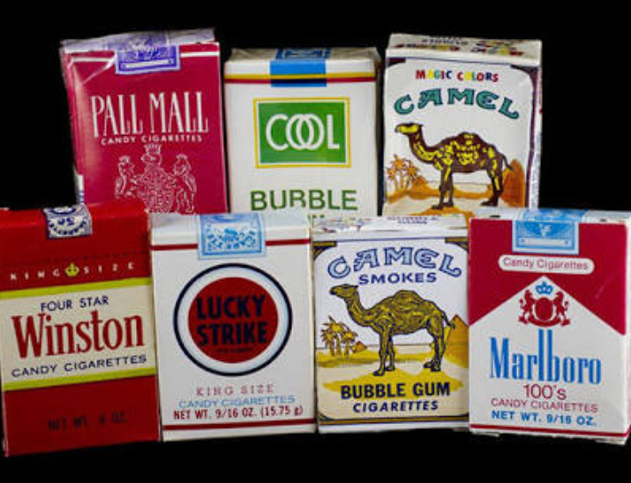

“The evil of those cigarette advertisers”, he would tell me in Hungarian, “trying to get kids when old enough to smoke real cigarettes.”

Indeed that evil never wore off on me. But the evil of loneliness and the threat that such dis-ease can have, which Nick Duerden says is “as deadly as smoking, as deadly as cancer”, is having a profound impact on the wellbeing of many who have lost connection with places like their local milk bar.
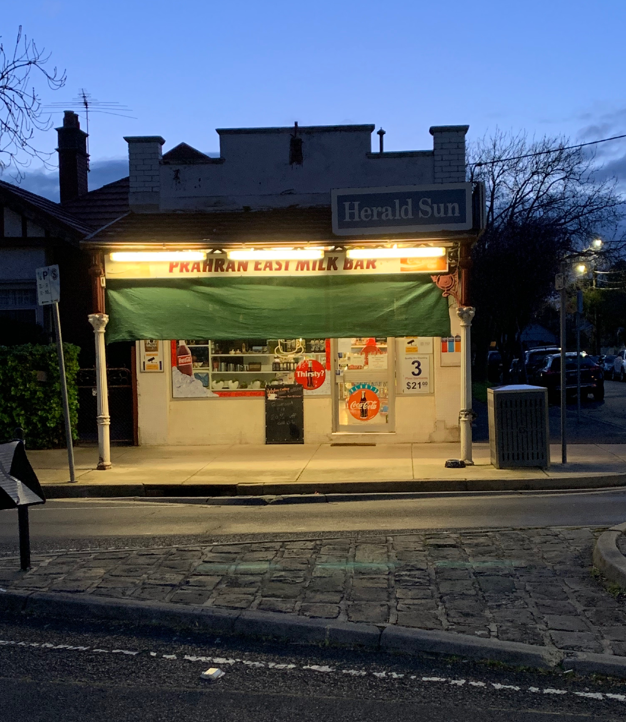
Source: Agnes Remay 9/9/19

For more information on Psychology Week 10-16 November to combat loneliness and discover new ways to meaningfully connect with others in the local community, please visit: https://psychweek.org.au

Note:

Some names have been changed for privacy reasons.

Interviewees:

- Jenny and Kevin Cheung, proprietors of Jenny’s Milk Bar (19/08/19; 20/08/19; 2/09/19)
- Jane and Lindon, proprietors of High Street Prahran Milk Bar (2/09/19)
- Maribel Steel, customer of Jenny’s Milk Bar (4/10/19)
- Steven Haby, senior librarian, historian and former patron of Aberfeldie Milk Bar (19/08/19; 29/08/19)
- PMI Volunteer, Kevin Powell, former owner of Kooyong Newsagency (22/08/19)
- Tibor Remay, former customer of Inkerman Street Milk Bar (My Dad at 91 and still talking about the good ol’ days at the local milk bar)
- Eamon Donnelly author of spectacular 2018 publication, The Milk Bars Book (7/10/19)
- Meni, Town Planner at Stonnington City Council (7/10/19)
- Sean Ross, Senior Communications Advisor at Stonnington City Council (7/10/19)
- Eleni from Neos Kosmos, Melbourne’s Greek newspaper in an effort to source exact details about the below photograph p. 85 from Eamon Donnelly’s work. (27/10/19)

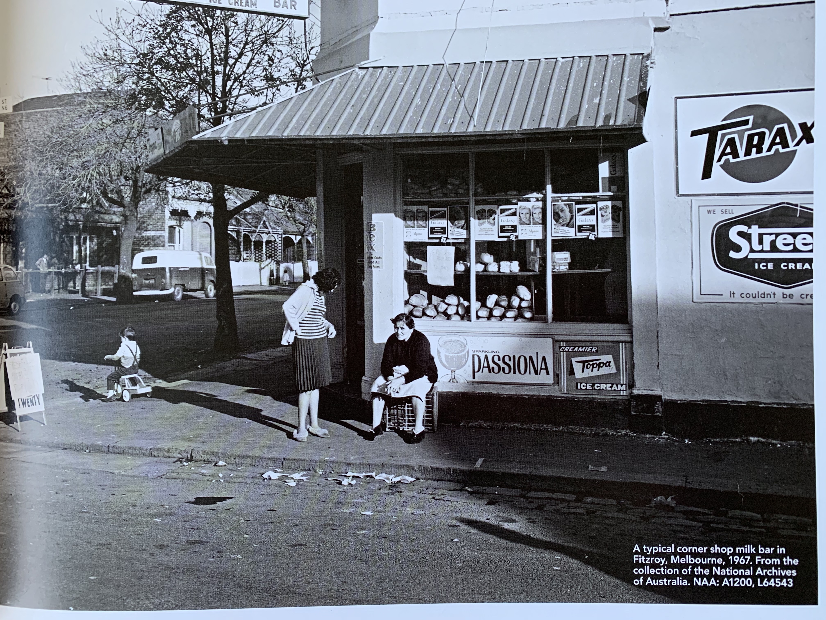

References/Sources:

- The Milk Bar Book by Eamon Donnelly
- Greek Cafes and Milk Bars of Australia by Effy Alexakis and Leonard Janiszewski
- Shirley Horne’s A Study of Milk Bars/Corner Shops in Melbourne: Shopping as a Social Activity
- Trove: National Archives
- Radio National: ABC Interview with Libbi Gore and Peter Mousaferiadis (6/05/18)
- Radio National: ABC Interview with Jacinta Parsons and Perrick Boyer and Michelle Lim (1/10/19)
- https://www.abc.net.au/news/2019-03-10/what-canberra-local-shops-are-doing-to-survive/10563154
- Facebook Images from Australia Remember When by Bob Byrne
- Google Maps
- http://mymagicdog.com/4583/service-dogs-action/
- https://www.healthdirect.gov.au/assistance-dogs
- www.supertectonics.com.au
- The Girl Who Hugs Dogs by Damian Balassone
- Supertramp’s Crime of the Century and School
- https://www.utas.edu.au/news/2019/8/20/909-much-more-than-milk-and-bread/
- https://www.theguardian.com/cities/gallery/2018/apr/11/melbourne-milk-bars-suburbia-in-pictures
- https://www.powerretail.com.au/multichannel/online-grocery-sales-up-39-7/
- Loneliness of Older Adults: Social Network and the Living Environment by Astrid Kemperman , Pauline van den Berg , Minou Weijs-Perrée and Kevin Uijtdewillegen. Department of the Built Environment, Eindhoven University of Technology, The Netherlands; a.d.a.m.kemperman@tue.nl (A.K.); m.weijs.perree@tue.nl (M.W.-P.); kevin_uytdewillegen@hotmail.com (K.U.) * Correspondence: p.e.w.v.d.berg@tue.nl; Tel.: +31-40-247-5417
- Australians at Risk by Anne Deveson
- https://abcmedia.akamaized.net/rn/podcast/2019/04/aim_20190407.mp3 Lynne Malcolm interview with Nick Duerden
- https://www.rrr.org.au/on-demand/segments/how-to-combat-social-isolation-with-hugh-mackay-on-the-grapevine (14/01/19)

