Science Tutors in Melbourne and Hobart

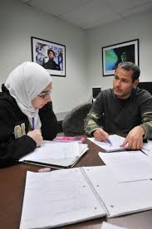
Science is a staple of primary and secondary education, and encompasses a range of fields that uncover how the world works. It’s a subject that delves deeply into everything from the intricate systems that form the human body and mind, to the heat energy produced by the sun, to the chemical reaction generated by mixing two parts hydrogen and one part oxygen. The study of Science demonstrates how these are all related to each other. In studying science, we study ourselves and the world around us.

Experienced science tuition tailored to the needs of each student
We offer experienced tuition in Melbourne and Hobart that covers the many fields of science. We’ve helped students gain the confidence needed while preparing for exams to catch up to their classmates when they’ve not been able to attend school for extended periods, improve their understanding so they can keep up in class or even help them excel if they’re aiming for careers in Medicine at VCE or TCE Year 12. Our qualified tutors can help students with: Biology, Chemistry, Physics and Psychology.
To learn more about how our science tutors can help, or to understand better the range of tuition services we provide for students of all ages, please call us on 0410 555 738 or send us an email at: a_plus_a_tutorials@bigpond.com.

