From Kindergarten through to Year 12, our English Tutors service Melbourne and Hobart wide. They are committed to helping all students achieve their short and long term goals.
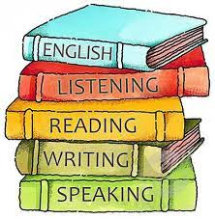
Our English tutor service is:
- Specifically tailored to engage and motivate individual learning styles.
- Serviced by fully qualified teachers – minimum three years’ experience and with VIT or TRB registration.
- Meets requirements of Australian English Curriculum.
- Provided in home or at our offices as preferred, to enhance learning.

