

From Kindergarten through to Year 12, our English Tutors service Victoria. They are committed to helping all students achieve their short and long term goals.
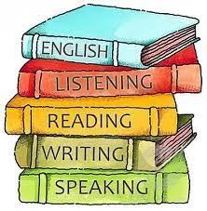
Our English tutor service is:
- Specifically tailored to engage and motivate individual learning styles.
- Serviced by fully qualified teachers – minimum three years’ experience and with VIT Registration or Working With Children Check Certification.
- Meets requirements of VCE Study Design and Australian English Curriculum.
- Provided in home or at our offices as preferred, to enhance learning.


